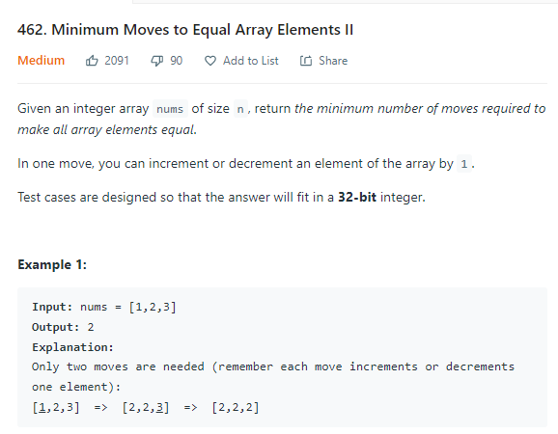

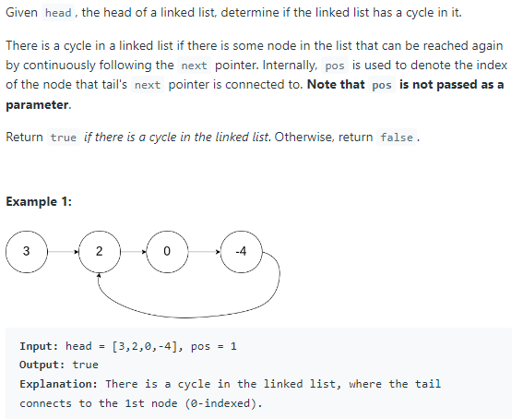

Chef's phone has a total storage of SS MB. Also, Chef has 22 apps already installed on his phone which occupy XX MB and YY MB respectively.
He wants to install another app on his phone whose memory requirement is ZZ MB. For this, he might have to delete the apps already installed on his phone. Determine the minimum number of apps he has to delete from his phone so that he has enough memory to install the third app.

Input Format
- The first line contains a single integer TT — the number of test cases. Then the test cases follow.
- The first and only line of each test case contains four integers S,X,YS,X,Y and ZZ — the total memory of Chef's phone, the memory occupied by the two already installed apps and the memory required by the third app.

Output Format
For each test case, output the minimum number of apps Chef has to delete from his phone so that he can install the third app.

Constraints
- 1≤T≤10001≤T≤1000
- 1≤S≤5001≤S≤500
- 1≤X≤Y≤S1≤X≤Y≤S
- X+Y≤SX+Y≤S
- Z≤SZ≤S

Sample Input 1
4
10 1 2 3
9 4 5 1
15 5 10 15
100 20 30 75

Sample Output 1
0
1
2
1

Explanation
Test Case 1: The unused memory in the phone is 77 MB. Therefore Chef can install the 33 MB app without deleting any app.

Eikooc loves bread. She has NN loaves of bread, all of which expire after exactly MM days. She can eat upto KK loaves of bread in a day. Can she eat all the loaves of bread before they expire?

Input Format
- The first line contains a single integer TT - the number of test cases. Then the test cases follow.
- Each test case consists of a single line containing three integers NN, MM and KK - the number of loaves of bread Eikooc has, the number of days after which all the breads will expire and the number of loaves of bread Eikooc can eat in a day.

Output Format
For each test case, output Yes if it will be possible for Eikooc to eat all the loaves of bread before they expire. Otherwise output No.
You may print each character of Yes and No in uppercase or lowercase (for example, yes, yEs, YES will be considered identical).

Constraints
- 1 \leq T \leq 10001≤T≤1000
- 1 \le N, M, K \le 1001≤N,M,K≤100

Sample 1:
Input
Output
3
100 100 1
9 2 5
19 6 3
Yes
Yes
No

Explanation:
Test case 1: Eikooc can eat one loaf of bread per day for 100100 days. Thus none of the bread expires.
Test case 2: Eikooc can eat 55 loaves of the first day and 44 loaves on the second day. Thus none of the bread expires.
Test case 3: There is no way Eikooc can consume all the loaves of bread before it expires.

